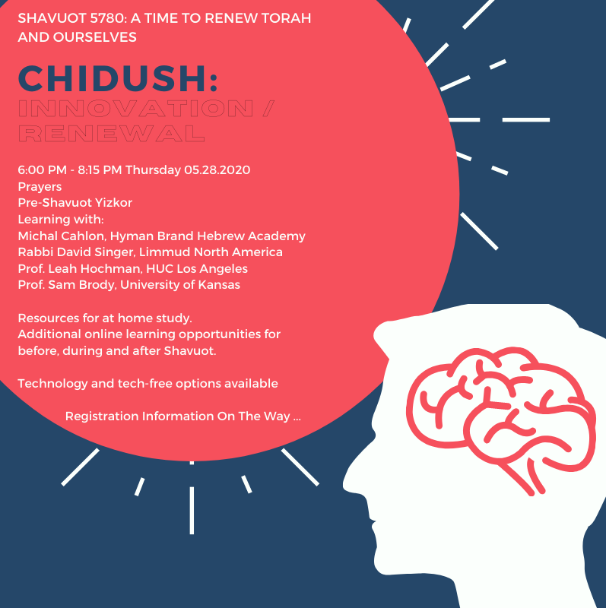

Pre-Shavuot Yizkor and Erev Shavuot Learning:
Thursday May 28, 2020 6:00 – 8:00 pm

Chiddush: Innovation / Renewal

An Evening by Zoom to welcome the Festival of Shavuot.
Prayer. Learning. Community.
BYOC – Bring Your Own Cheesecake

All events happen in the Zoom Space for Daily Minyan. Click here to enter.
During the learning sessions, we will split the group into two Zoom Breakout Rooms.

6:00-6:15 PM Daily Minyan

6:15-6:30 PM Pre-Shavuot Yizkor

6:30-7:15 PM Session I

Breakout Room A: Rabbi David Singer, Executive Director, Limmud North America. Animating Change: Innovating Toward a Brighter Jewish Future

Breakout Room B: Professor Sam Brody, Assistant Professor of Religious Studies, University of Kansas. Unprecedented: New Relations between Jews and Others in the Late 20th/Early 21st Centuries

7:15 PM Session II

Breakout Room A: Professor Leah Hochman, HUC Los Angeles. Tell Your Story, Change the World: Memoirs, Memories and Making Meaning (Looking at Glueckl of Hameln)

Breakout Room B: Michal Cahlon, Hyman Brand Hebrew Academy. Bad New Good New: Jewish Responses to Change

Are you interested in joining an all-night learning program online for Shavuot?

Are you interested in creating your own all-night learning at home? Click here <<Link on our Website>> for amazing resources.

Friday Morning Livestream Service, May 29, 2020
10:00– 11:00 am
www.bethshalomkc.org/livestreaming

WE WILL NOT HAVE CONNECT FOR SHABBAT, FRIDAY MAY 29, 2020. WE’LL RETRUN JUNE 5TH, 2020

Saturday Morning Livestream Service, May 30, 2020
10:00 am – 11:00 am with Yizkor
www.bethshalomkc.org/livestreaming

Saturday Evening Havdalah, May 30, 2020
9:30 pm on Facebook Live http://www.facebook.com/bethshalomkc/video

