Our Kids & Teens are Engaged and Experiencing Jewish Living

Our Youth and Family Programming department provides a variety of activities, programs and initiatives to connect our youth and teens and engage them in Jewish living experiences.

Our goal is to provide fun, innovative and educational experiences to enrich their Jewish identity. Opportunities abound for both informal Jewish educational and social activities. More important, our youth programs provide a place where lifelong friendships begin, everyone has a place, and leadership opportunities abound.

Our youth activities offer age-appropriate events and activities, overseen by our Director of Youth & Family Programming. Each program offered through the youth department is appropriately staffed based on the age group and nature of the activity, and strictly adheres to the guidelines set by the United Synagogue of Conservative Judaism.

Beth Shalom’s youth programs include:
- USY – High School
- Kadima – 7th and 8th graders
- Gesher – 5th and 6th graders
- Atid – 3rd and 4th graders
- Scout Troop 61 (overseen by our Scouting Committee)

KCUSY - Engaging our Teenagers

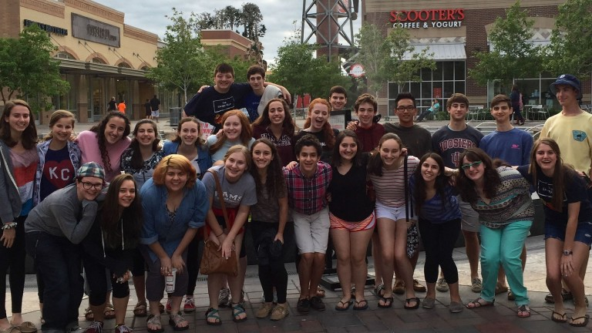

Our award-winning chapter of United Synagogue Youth (USY) brings Jewish high school students from public and private high schools together for activities that promote learning, socialization, leadership and responsibility. Weekly Wednesday Night Programs include social, cultural, religious, community service and fundraising activities. Additionally, members have the opportunity to attend several regional and international programs each year.

Don’t Miss Out on the Fun – Join Us!
KCUSY Membership Application

Kadima - Engaging 7th & 8th Graders

Kadima is Beth Shalom’s youth group for seventh and eighth graders. Under the guidance of our Director of Youth & Family Programming, members engage in fun monthly programs, help organize and run the KCUSY Annual Purim Carnival, and have the opportunity to participate a regional convention with other youth from throughout the Midwest.

Don’t Miss Out on the Fun – Join Us!
Kadima Membership Application

Gesher - Engaging 5th and 6th graders

The perfect social opportunity for fifth and sixth graders, Gesher serves as the bridge to Kadima. Students meet once a quarter. Check out our exciting Gesher experiences.

Don’t Miss Out on the Fun – Join Us!
Atid – Engaging 3rd and 4th graders

Offered quarterly, Atid programs offer third and fourth graders the opportunity to make Jewish friends.

Gesher & Atid Parent Survey

For more information on any of our youth department programs, please contact our Director of Youth & Family Programming.

Don’t Miss Out on the Fun – Join Us!

